

**Call for Applications;**

**WOYODEV Board Recruitment**

**Organization:** Women Environment and Youth Development Initiative (WOYODEV)

**Location:** 5, Redcross road, off Offa Road, GRA, Ilorin, Kwara State

**About Us:** The Women Environment and Youth Development Initiative (WOYODEV) is a dynamic NGO dedicated to empowering women, protecting the environment, and supporting youth development. We seek passionate and experienced individuals to join our Board of Trustees.

**About the Board:** Our Board work to provide strategic guidance, oversight, and governance, supports the management team to ensure the organization's mission and objectives are achieved.

**Responsibilities:**

1. Provide strategic direction and governance for the organization.
2. Oversee organizational performance and risk management.
3. Ensure compliance with laws, regulations, and governance standard.
4. Foster relationships with stakeholders, partners, and donors.
5. Assist in fundraising and resource development.
6. Oversee financial management and budgeting.
7. Support and evaluate the Executive Director.
8. Represent the organization in the community

**Requirements:**

- Proven track record of leadership and expertise in a relevant field (e.g., international development, healthcare, education, governance, environment, data management, finance amongst others.)

- Strong understanding of governance, finance, and strategic planning

- Excellent communication, interpersonal, and analytical skills

- Ability to commit to regular board meetings and activities (approx. 4-6 times per year)

**Desirable Qualifications:**

- Experience serving on a board or similar governance structure

- Knowledge of the non-profit sector and current trends

- Professional certifications (e.g., MBA, CPA, etc.)

- Fundraising and resource mobilization experience

- Research and documentation skills

- Visionary leadership

**What We Offer:**

- Opportunity to contribute to a meaningful cause

- Collaborative and dynamic work environment

- Professional development and networking opportunities

**Time Commitment:**

Board meetings are held bi-annually, with additional committee meetings as needed. Each board member is expected to dedicate approximately 5-10 hours per month to board-related activities.

**How to Apply:**

If you are a motivated and dedicated individual passionate about making a difference, please complete the application form online, uploading the following document and submit:

- A cover letter outlining your interest, qualifications, and experience.

- A comprehensive CV

***OR download the form, complete and attach the above document, send to*** [***recruitments@woyodev.org***](mailto:recruitments@woyodev.org) ***with the subject title:*** Application for Board Membership ***by 24th February, 2025.***

**Equal Opportunity Employer:**

WOYODEV is committed to diversity, equity, and inclusion. We encourage applications from individuals of all backgrounds and experiences.

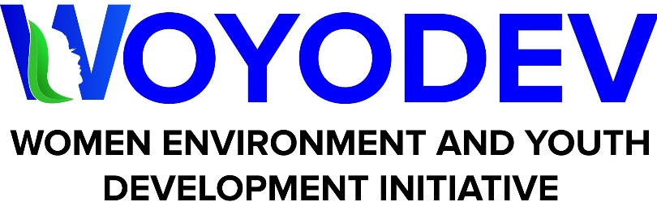

**BOARD MEMBERSHIP- CALL FOR APPLICATION**

**APPLICATION FORM**

Surname:

First Name:

Other Name:

Gender:

Date of Birth:

Physical Address:

Email:

Phone Number:

Educational Qualification (Highest Level of Obtained):

Profession:

Place of Work:

Position/ Role:

Motivation For Submitting an application:

How do you think you can contribute to the growth and development of the organisation:

Board role is on voluntary basis which requires 5-10 hours’ time commitment per month; are you willing to take up the role:

Provide Details of Two (2) Referees Below:

***Referee 1***

Referee’s Name:

Referee’s Email:

Referee’s Phone Number:

***Referee 2***

Referee’s Name:

Referee’s Email:

Referee’s Phone Number:

Attachments:

-A cover letter outlining your interest, qualifications, and experience.

- A comprehensive CV